Name: ________________________________ Date:________

**Congruent Triangle Proofs Day 4 (Overlapping)**

**1.**





**2.**



**Given: **





**Prove: **

**3.** In the diagram of  below,  and medians  and  are drawn.

Prove: 

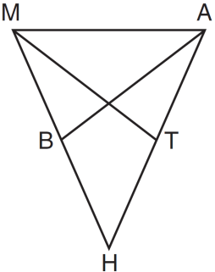

4.

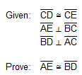

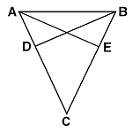

**5.**

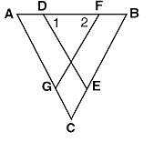

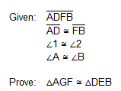

**6.**

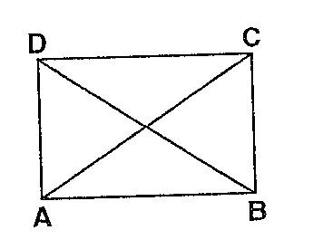



7. The diagram below shows a pair of congruent triangles, with  and .

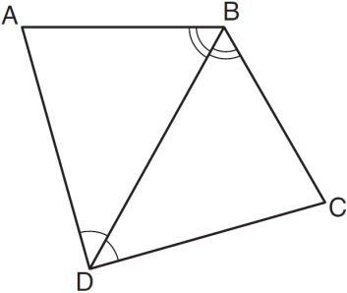

Which statement must be true?

|  |  |
| --- | --- |
| 1) |  |
| 2) |  |
| 3) |  |
| 4) |  |

8. In the diagram below, .

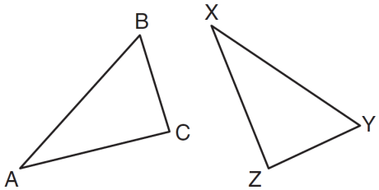

Which two statements identify corresponding congruent parts for these triangles?

|  |  |
| --- | --- |
| 1) |  |
| 2) |  |
| 3) |  |
| 4) |  |

**9.** If , which statement is always true?

|  |  |
| --- | --- |
| 1) |  |
| 2) |  |
| 3) |  |
| 4) |  |

10. In  shown below with , , , and , .

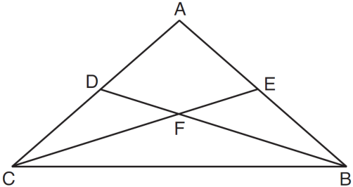

Which statement must be true?

|  |  |
| --- | --- |
| 1) |  |
| 2) |  |
| 3) |  |
| 4) |  |